We need to encode a given text following the next rules:

The spaces should be removed. Being ***L*** the length of the text, the characters are written in a table whose rows and columns must meet the following conditions:



Example:

**we the people of the united states in order to form a more perfect union etc**

After removing the spaces, it is ***61*** characters long. So, we write it as a table with 8 rows and 8 columns:

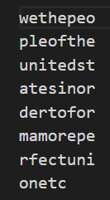

* Make sure that ***rows * columns >= L***
* If there are more than one table that satisfy these conditions, choose the one with the minimum area.
* The result message is created by displaying the characters in a column, inserting a space, and repeating the process with all columns.

Expected result for above example:

**wpuadmro elnteafn teiermee hotstoct efeiortc ptdnfeu ehsoopn oetrrei**

**Input sample:**

cheating is not allowed

**Output:**

cinl hnoo egtw aiae tsld

**Input sample:**

the rocks

**Output:**

trk hos ec